Auto Ticket Classification using Flow Designer
Part 6 of 7 — Testing, Validation & SecurityPart 6 of 7 — Testing, Validation & Security

Phase 6: Testing, Validation & Security
This phase validates the end-to-end automation, confirms data accuracy, and ensures that only authorized users can access or modify ticket data.

Data Validation Checks
- Mandatory fields captured correctly.
- Auto-number generated without duplication.
- Category and Subcategory values stored accurately.
- Reference fields resolve correctly to user and group tables.

Activity 1: Testing & Validation — Test Scenario 1
- Enter one Caller Name.
- Short Description: WiFi not working in library.
- Then Save the Form, and Reload the Form.
- It fills auto as: Category → Network, Subcategory → WiFi.
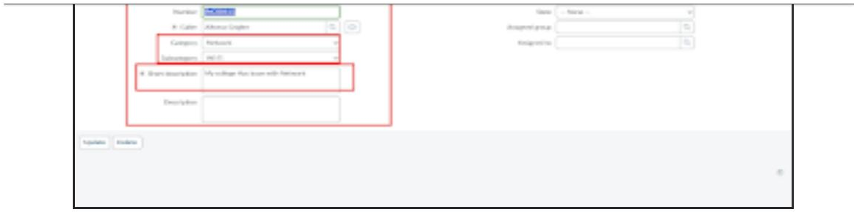

Activity 2: Check Email Notification
- Open All menus → Search Emails.
- Under System logs → Select Emails.
- Search with the given Subject Name.
- Open that record and, under Related Links, click Preview mail Option.
- Email sent to caller Email Id.
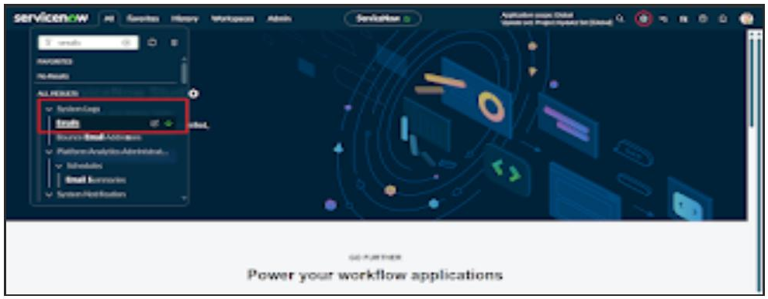
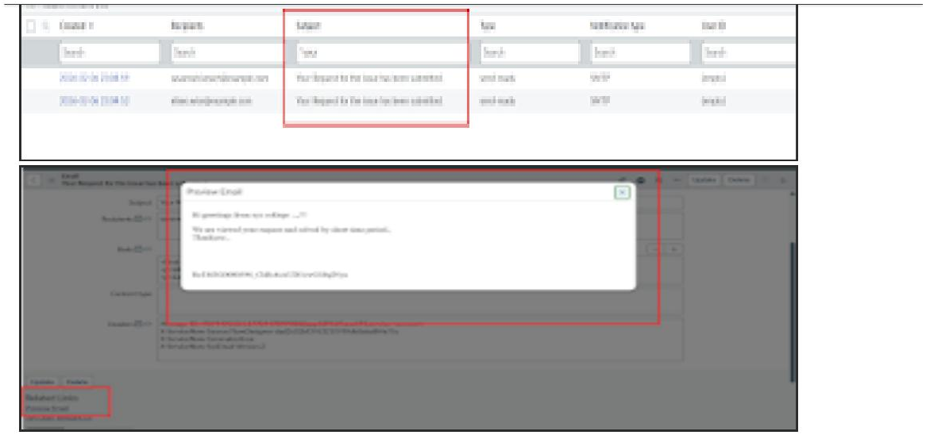

Activity 3: Test Scenario 2
- Enter one Caller Name.
- Short Description: Projector not turning on.
- Then Save the Form, and Reload the Form.
- It fills auto as: Category → Hardware, Subcategory → Projector.
- Then email sent to caller Mail id.
